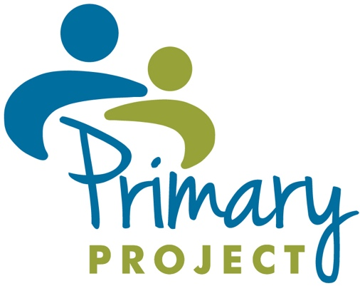

Dear Parent/Guardian(s) of:

We are excited to offer Primary Project at our elementary school. Primary Project is designed to help children feel good about their school experiences. Your child has been selected to participate. Please sign the permission below and return it to school as soon as possible, if you’d like your child to participate.

Students meet once a week for 30 minutes over the course of 12-15 weeks. Your child will have the opportunity to work with a specially trained child associate and engage in child directed/expressive play activities. Through play, children learn skills of expressing feelings and problem solving.

If you have any questions please contact, Click or tap here to enter text. , the (i.e. program coordinator, school social worker, counselor or psychologist), at Click or tap here to enter text. .

We look forward to having your child in Primary Project this year.

Sincerely,

Elementary School Principal
-----------------------------------------------------------------------------------------------------------------------------------------

________________________________________ has my permission to participate in Primary Project.
Student’s name

Please check off below on either in-person, virtual, or both:

☐Student has permission to participate in in-person sessions.
☐Student has permission to participate in virtual sessions.

____________________________ _____________________________________ ____________
Teacher’s name Parent/guardian signature Date

__________________________________________________________ _____________________
Parent/guardian’s address Phone number

