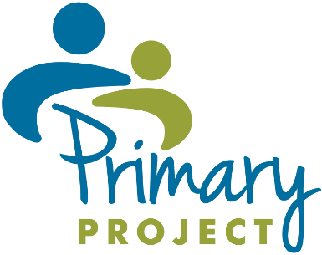
In-Person Certification Process and Virtual Meetings via Zoom Certification Process Form
Below is a description of how National Certification visits will be offered this year (in-Person or Virtual Processes). Please check the box indicating which process your school prefers. Indicate in the fields below the name and e-mail address of the person at your school who will be responsible for uploading the certification documents to your school’s secure folder.

This form is due to Arlene Bobin (abobin@childrensinstitute.net) and Kathy Embt (kembt@childrensinstitute.net) on or before
November 8, 2022. Application documents must be uploaded to your secure folder no later than January 27, 2023.

Process preferred: ☐ In-Person Certification Process ☐ Virtual Meetings via Zoom Certification Process

Name of person uploading documents: Click or tap here to enter text.
E-mail address of person uploading documents: Click or tap here to enter text.

In-Person Certification Process |  | Virtual Meetings via Zoom Certification Process
Upload certification application documents to the secure folder by  January 27, 2023. |  | Upload certification application documents to the secure folder by January 27, 2023.
Let Arlene Bobin know that the documents are uploaded. |  | Let Arlene Bobin know that the documents are uploaded.
After endorser assignments are made, you will receive an e-mail introducing your endorser so that you can agree on a date for the 3.5-4 hour in-person visit to your school. |  | After endorser assignments are made, you will receive an e-mail introducing your endorser. You can schedule a date for your first Zoom meeting.
Complete a draft agenda using the In-Person Certification Visit Agenda Guidelines and submit it to your endorser for approval, at least 2 weeks before the scheduled visit. |  | After the 1st Zoom meeting, you will be given survey links to send to parents, teachers and an administrator. (The surveys take 5 minutes or less to complete.) Once the surveys are completed (your endorser will let you know when this occurs), you will be able to schedule the 2nd and 3rd Zoom meetings.
Complete the certification visit. |  | Complete the 2nd and 3rd Zoom meetings.
Complete the certification feedback survey that will be sent to the indicated persons on your certification application. |  | Complete the certification feedback survey that will be sent to the indicated persons on your certification application.
Receive a letter indicating your certification status (about 2 months after visit completion). |  | Receive a letter indicating your certification status (about 2 months after visit completion).

